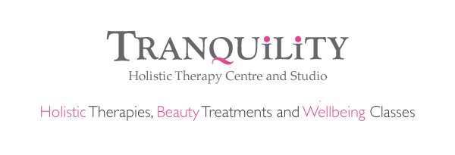
Inner Dance Meditation for Parents and Children with ASD

16th September 2017, 28th October 2017, 25th November 2017

6pm – 7.30pm

£10 per adult and child Introductory offer
£5 per additional child

For parents and children with ASD from7 years

A workshop specifically designed for you to attend with your child

A shorter Inner Dance session to allow your child to be themselves in a safe space where there is no judgement and no rules! A personal journey with music and guided meditation

Lots of sensory things – Music, massage if liked (not compulsory if not liked) and healing for you both in this special workshop

Doors will be open and you are free to leave whenever you need to

TO BOOK VISIT WWW.TRANQUILITYEVENTS.CO.UK WHERE YOU WILL BE GUIDED TO OUR EVENTBRITE PAGE TO BOOK AND RESERVE YOUR PLACES ONLINE

