Reiki 1 Course
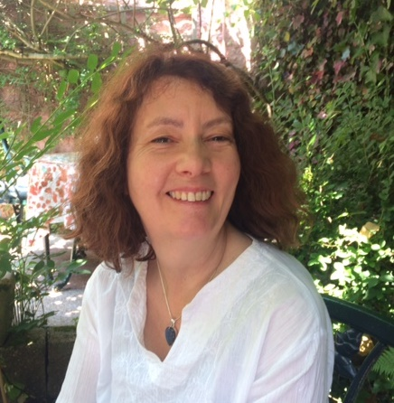
Hello my name is Helen Taylor. I run Helen’s Holistic Therapies and I’m a Reiki Master Teacher. I’m very excited to announce that I’m running a Reiki 1 course at Tranquility on Tuesday the 5th November 2019 from 10am-1pm for 4 consecutive weeks. The price will be £150 including a manual and cd as well as 12 hours tuition.
Reiki is a wonderful therapy and can be used to help you sleep better, reduce stress and enhance relaxation.
By the end of the course you will understand:
- What Reiki is and the benefits.
- The history of Reiki and the 5 principles.
- The chakras and energy system.
- Learn how to carry out a reiki treatment for yourself and others.
- How to ground and protect yourself.
If you would like to know more about this wonderful therapy or would like to book on this course please contact me on 07806634781 or email me helen@httherapy.co.uk.

